
rpo

Arasva client Assignment
11th Dec, 2025
NeoSOFT is a SEI-CMMI Level-5 Global IT Consulting & Software Solutions Provider
Document Control Sheet
Current Version | 1.0
Project Name | Arasva client assignment
Document Type | Explanation document of API and assignments
Author | Yalla Reddy
Document Creation Date | 11-12-2025
Last Updated Date | 11-12-2025

Revision History
Version | Date | Name | Comments
1.0 | 10-12-2025 | Yalla Reddy | Explanation document

Contents

SUMMARY

Arasva client assignment to create the solution and work on the requirement document things. So, as NeoSOFT resource, Mr. Yalla Reddy worked on them and completed. This document will give over view of the requirement and guidelines to run them.

Technologies used

Entities | Technology
API | .NET 9
Database | MS SQL
Code Repository
All code changes are pushed to GitHub account which is public one we can access the code from below link or using .git file which mentioned below.
https://github.com/YallaReddyNeo/ArasvaAssignment
https://github.com/YallaReddyNeo/ArasvaAssignment.git

API solution and architecture
Once we clone the code from above the git, we need to open the solution *ArasvaAssignment.sln* on the visual studio. Folder structure will be like below.
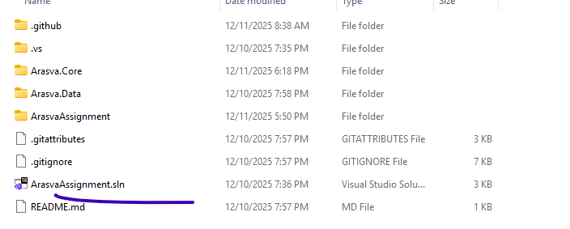
We have followed Service oriented architecture in this project with below format of solution. It contain 2 Web API and 2 class library of Arasva.Data and Arasva.Core projects.
Also, we have code first approach for quick development as its asking the requirement to go with EF Core technologies.

u ]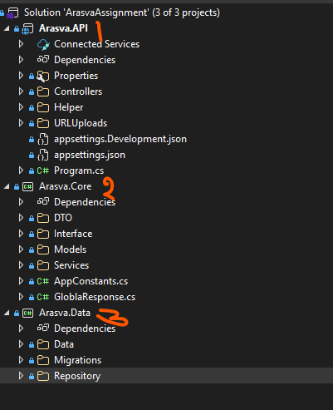
src/
│── Arasva.API/
│ ├── Controllers/ //Contains controller and its available methods
│ ├── Helper/ //Contains document and other useful files in this folder
│ ├── Program.cs

│── Arasva.Core/
│ ├── DTO/ // Collection of DTO used for data exchanges between controllers, Data access.
│ ├── Interface/ //Interfaces used to refer the services for core implementations. This folder repository things.
│ ├── Model/ //This contains database entity names here.
│ ├── Services/ //This contains services which used to communicate b/w UI and Data layer & this folder further Implementation and Interface folders.

│── Arasva.Data/
│ ├── Data/ //This contains AppDbContect.cs file which deals all DB things.
│ ├── Migrations/ // This contain all migration related history files
│ ├── Repositories/ //This contains Repository implementation which deals with Database objects and used to perform CRUD actions.

Database connection
As of now, solution is connected to NeoSOFT DB and we can change this connection as your requirement. This is only place we need to in entire solution and rest all other things take care automatically as per the connection string.
This connection is available in appsetting.json file of Arasva.API solution.
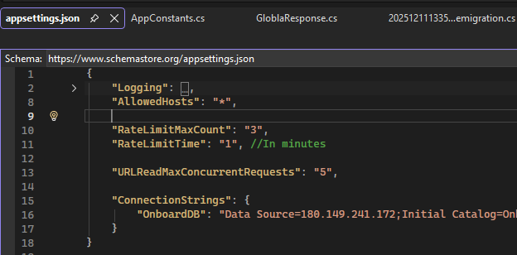

EF Migration
We need to run the migration from Package Manager Console for any model related changes to be pushed to DB automatically without doing them manually. We need to add-migration “migration comment”and then update-database command like shown in below. Please make sure we selected Arasva.Data project for this.
PM> add-migration samplemigration
Build started...
Build succeeded.
To undo this action, use Remove-Migration.
PM> update-database
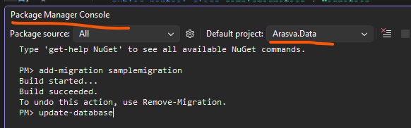

If the above the things are clear then, we will go and run the project and execute the assessment output.

Assignment I
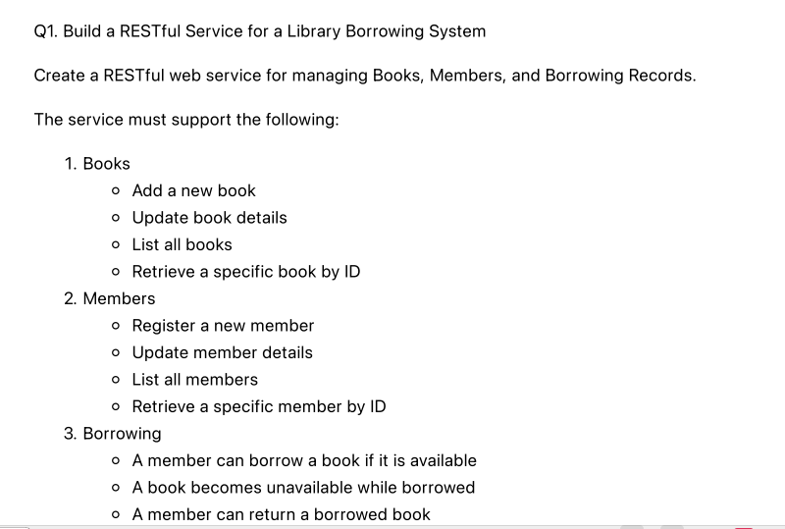
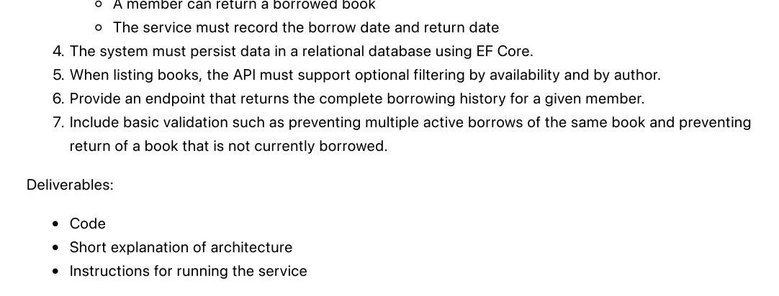

Impementation:
For this, we have create 3 controller and respected methods of below.
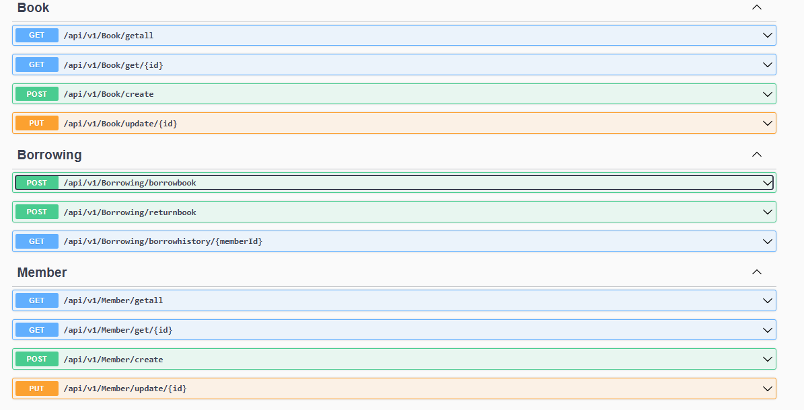
Explanation for each point is being explained in the ReadMe_ArasvaLibraryApi.txt file. We can refer how each method works.

Assignment II:
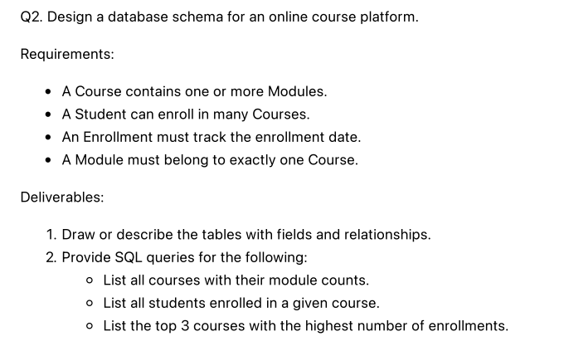
Impementation :
For this requirement changes, I have created database file and for questions, answers been implemented. We need to run this .sql file in the MS SQL and try to check the result. Once we ran it, it will take care of create tables, create data into them and getting desired outputs. Please refer the file Q2_Fixes.sql

Assignment III:
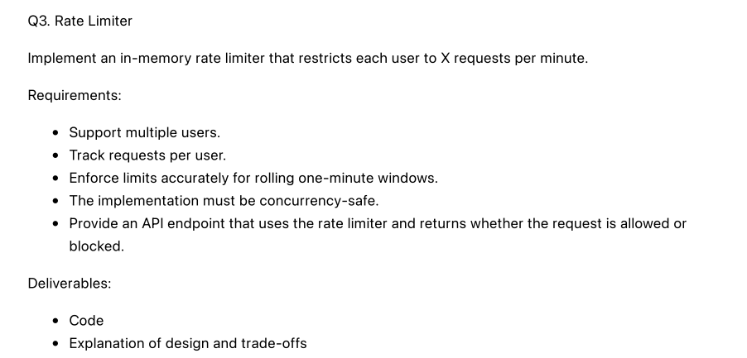
Impementation :
We have implement this functionality in RateLimit controller. To implement this, we have used RateLimitPartition concept and created policy RateLimitPolicy in the program.cs file.
In this policy, we have set time limit per user to get the access of a method. If the particular reaches max count (which we configured in appsetting.json file) then they get error. So, any particular user, can call this API max 3 times with in one minute (as per configure, which can be changed as wish).
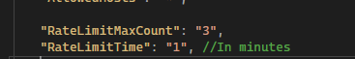

Same policy applied on RateLimit controller method as attribute of EnableRateLimiting like below.
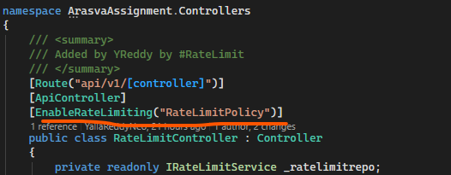
If limit is not reached for that user, they gets success response like below.
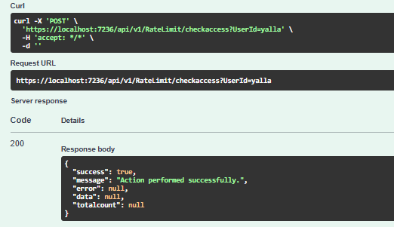
If particular user reached max limit of 3 of call with in 1 minute then user gets error of below.
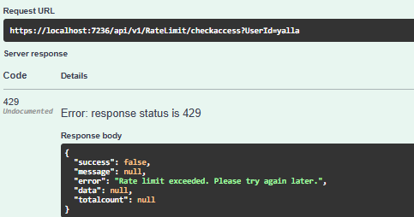
After one minute, count will be reset and they can able to access the end point.

Assignment IV:
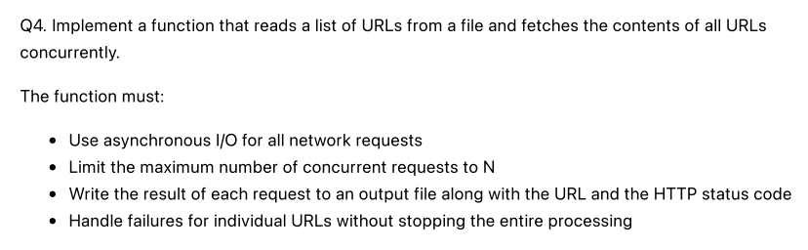
Impementation :
We have created a controller ReadURLContentController with method readurlcontent for his requirement. This method allows the user to upload Q4_Request.txt file as request body and it’s the URL content/data one by one using HTTP client with async and await approaches. Then reads data for each url and save the results in the file ..\URLUploads\Response_639010797942802582Q4_Request.txt.
We are allowed to configure maximum concurrent request at once time using appsetting.json file here.
Each URL response is save into that file in the asked format.

** End of the Document**

